

User Guide Document

Team 29



University of Sussex

Table of Contents

Introduction 3

# Introduction

**Hardware requirements**

* 256mb of ram
* 5gb of hard drive
* VGA 640x480 or higher resolution screen
* Pentium 90MHz or higher microprocessor

**Software requirement**

* Java Runtime environment 8 (JRE)
* Windows vista or above
* Mac OS x 10.9 or higher

|  |  |  |
| --- | --- | --- |
| **Steps** | **Screenshot** | **Comments** |
| 1 |  | When the software is opened, the first screen that will displayed will look like the screenshot.  Currently there is data on the graph because we need load in the data file. |
| 2 |  | To load the data file, click on the file tab in the menu bar and click load file.  Toe exit the software, it can be done by clicking the exit option or by clicking the red button at the top left of the screen. |
| 3 |  | The data file needs to be located using the file locator screen. Click the file and press open. |
| 4 |  | Once the file has been loaded, there will be additional items appearing on the screen. At the bottom of the screen there will be the clients name.  The simulation setting can be adjusted to show the simulation quicker.  In order to run the simulation, press the ‘**Run’** Button. |
| 5 |  | Once you have pressed run button, the graph will show the data file on the graph.  In the simulation information. There are 2 pieces of information, one being the market state which will change as the simulation progresses.  The second piece is the simulation date which will change to update the graph every 15 minutes.  The simulation can be stopped by clicking the ‘**Stop’** Button. |
| 6 |  | The advance interval button advances the simulation 15 minutes.  There are 3 tabs, client, companies and exchanges. You change between tabs as the simulation runs. |
| 7 |  |  |

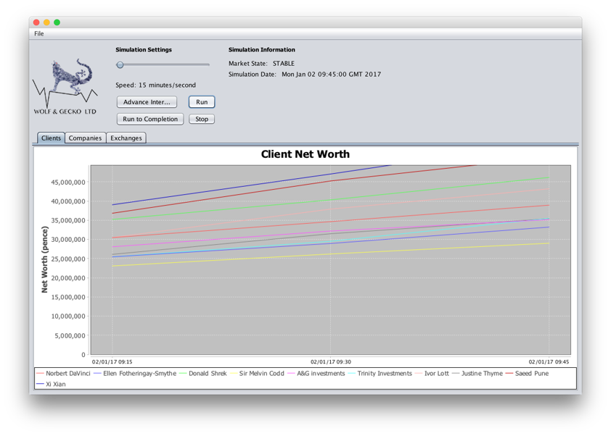

Speed of simulation can be increased.

This button will run the simulation to the 31st of January 2017

Advances the simulation to next 15 minutes.

The simulation will stop.

Once data has been loaded. The run button launches the simulation.

Simulation date. Displayed in GMT and will change as simulation advances.

The market states. This will change as the simulation advances.

Clients name and line colour which will showed on the graph.

Load data into the simulation.